**Report for**

**COMP 472 Project Assignment #1**

**Prepared by**

**Peng Zhao 40070966**

**Moben Li 40078435**

**Qichen Liu 40055916**

**Fuqiang Zhai 40072577**

**Project repository:** https://github.com/limoben/COMP472_AI_Face_Mask_Detector.git

**Concordia University**

**04/06/2022**

# **1. Contribution Log**

| **Group Member** | **Contribution:**  (I) Data Specialist, responsible for creating, pre-processing, loading & analyzing the datasets;  (II) Training Specialist, responsible for setting up and training the CNN;  (III) Evaluation Specialist, responsible for analyzing, evaluating, and applying the generated model;  (IV) Compliance Specialist, responsible for the overall planning, scope verication, and compliance  (in part 2 of the project, this member will also be responsible for the new tasks mentioned below). |
| --- | --- |
| Peng Zhao  40070966 | (I) Data Specialist, responsible for creating, pre-processing, loading & analyzing the datasets;  (II) Training Specialist, responsible for setting up and training the CNN; |
| Qichen Liu  40055916 | (II) Training Specialist, responsible for setting up and training the CNN;  (III) Evaluation Specialist, responsible for analyzing, evaluating, and applying the generated model; |
| Moben Li  40078435 | (I) Data Specialist, responsible for creating, pre-processing, loading & analyzing the datasets;  (IV) Compliance Specialist, responsible for the overall planning, scope verication, and compliance |
| Fuqiang Zhai  40072577 | (II) Training Specialist, responsible for setting up and training the CNN;  (III) Evaluation Specialist, responsible for analyzing, evaluating, and applying the generated model; |

**Dataset**:

The dataset for this project is coming from different sources(see reference). The main source of our image is from Kaggle, which counts approximately 85% of our total image. We download 5 dataset from Kaggle, and manually sort them to have 4 kinds of mask image into 4 different folders.

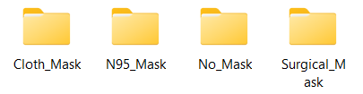

At the end of sorting process, we found out that the N95 mask is much less than other types images. Therefore, we go to google image by searching “N95 mask” key word to get list of image. We pick and save the image to local folder. After we have enough image, we found that the image has a different file type, include .jpg .jpeg .png. We convert all the image to .jpg file type to avoid the potential type error. All the image are in high resolution with full clear face and mask, although some of image are in landscape and some are in portrait. Finally, the 4 class of has 409, 405, 469 and 406 images respectively, a total of 1689 image.

After manually processing the image, we start using python code to further pre-process the image. First, we use pyTorch transforms function to transform the image to the same property, which are resize image to 32 *32, convert image to tensor, and normalize the image. Then we load the image through torchvision.datasets.ImageFolder function, after that, we use DataLoader to load train data and test data specifictly.

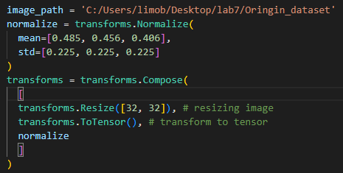



**CNN Architecture**:

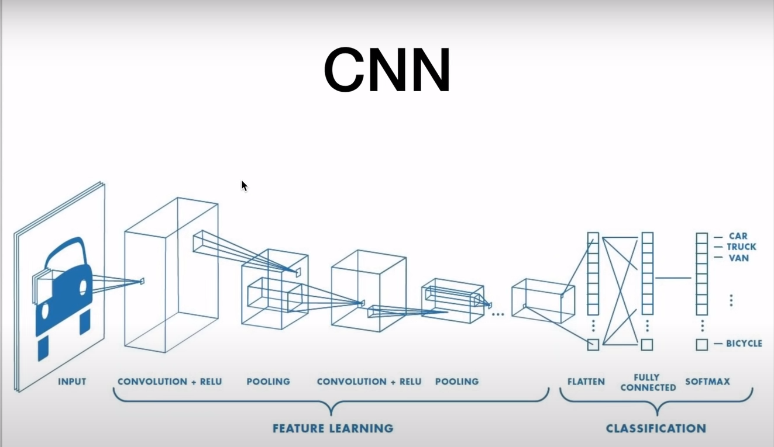

The image above shows the the main structure of CNN Architecture which combined with a 1st convolutional layer followed with a relu activation function, then apply the max pooling layer, and 2nd convolutional layer followed with a relu activation and max pooling, after that , we have three different fully connected layers.

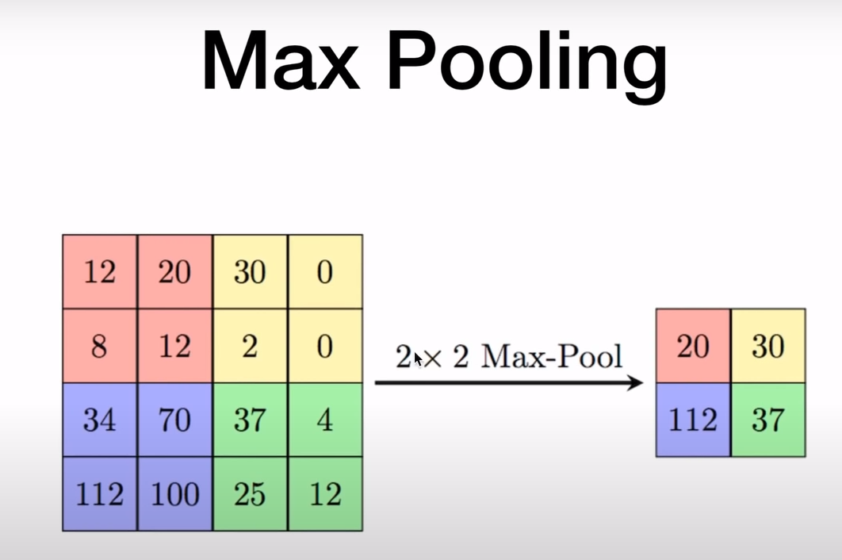

Max Pooling layer is used to reduce the computational cost by reducing the size of images. also avoid overfitting by providing an abstracted form of the input

In details:(explain some important layers implementation)

**self.conv1 = nn.Conv2d(3, 6, 5)**

the first convolutional layer passed three parameters, 3 stands for 3 color channel, the output channel size is 6 and the kernel size is 5 (5*5)

**self.pool = nn.MaxPool2d(2, 2)**

**self.conv2 = nn.Conv2d(6, 16, 5)**

the max pooling layer with kernel size 2*2

For the second convolutional layer, the input channel size is 6,which is the output of the first conv channel, and output channel size is 16.

self.fc1 = nn.Linear(16 *5 *5, 120)

For the 1st fully connected layer. the input size is 16*5*5 , since the original size of image is 32*32, and we calculate the result by applying the formula (W-F + 2P)/S + 1, W is input , F is the filter size, P stands for padding value and S is stride.and the result is 16 * 5 * 5 after two conv layers and 2 max pooling layers.

self.fc3 = nn.Linear(84, 4)

For the final fully connected layer , with the input 84 stands for the output of the previous fully connected layer.the second parameter value is 4, which stands for four different classes.

Training :

loop over the number of epochs that we set it to 6

loop over the train_loader , get images and labels of each batch,

then we do typical forward pass and create loss

in each loop , we need to empty the gradiance with the function zero_grad()

and finally calculate the accuracy

**Evaluation**:

For evaluation purposes, we used our implemented CNN model to test the 400 random images from 4 categories of masks based on our dataset. Then we plot the confusion matrix to and calculate the value of accuracy, precision, recall and F1-measure. Following is result we get from the test:

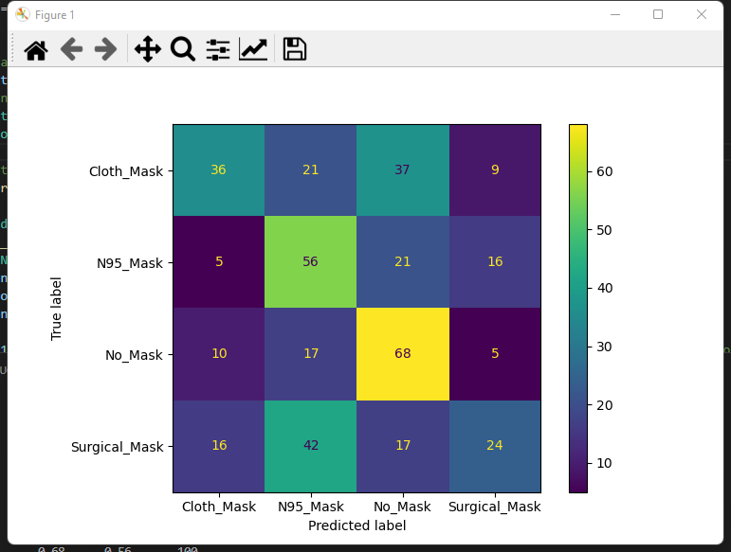

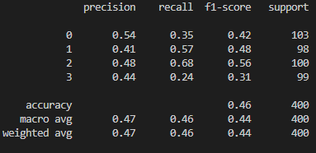

In the figure above, we can see that the accuracy of our model reaches 46%. This value is acceptable because we have not optimized our model yet. In the second phase of the project, we are going to expand our dataset to improve the accuracy. A larger dataset means that more images can be used to train our model. In addition, we can try to change the learning rate and number of epochs to improve the model accuracy.

In the evaluation process, we found out that as we increase the number of epoch, the accuracy is increasing, the precision and recall are also increasing.

**Reference:**

Reference1:

pytorch training video, (<https://www.youtube.com/watch?v=c36lUUr864M>)

Reference2:

kaggle dataset

dataset1:

https://www.kaggle.com/datasets/dhruvmak/face-mask-detection?resource=download

dataset2:

https://www.kaggle.com/datasets/prithwirajmitra/covid-face-mask-detection-dataset

dataset3:

https://www.kaggle.com/datasets/ashishjangra27/face-mask-12k-images-dataset

dataset4:

https://www.kaggle.com/datasets/perke986/face-mask-segmentation-dataset?select=images

dataset5:

https://www.kaggle.com/datasets/humansintheloop/medical-mask-detection

google image

https://images.google.ca/

**Faculty of Engineering and Computer Science**

**Expectations of Originality**

This form sets out the requirements for originality for work submitted by students in the Faculty of Engineering

and Computer Science. Submissions such as assignments, lab reports, project reports, computer programs and

take-home exams must conform to the requirements stated on this form and to the Academic Code of Conduct.

The course outline may stipulate additional requirements for the course.

1. Your submissions must be your own original work. Group submissions must be the original work of the

students in the group.

2. Direct quotations must not exceed 5% of the content of a report, must be enclosed in quotation marks,

and must be attributed to the source by a numerical reference citation1. Note that engineering reports

rarely contain direct quotations.

3. Material paraphrased or taken from a source must be attributed to the source by a numerical reference

citation.

4. Text that is inserted from a web site must be enclosed in quotation marks and attributed to the web site

by numerical reference citation.

5. Drawings, diagrams, photos, maps or other visual material taken from a source must be attributed to that

source by a numerical reference citation.

6. No part of any assignment, lab report or project report submitted for this course can be submitted for

any other course.

7. In preparing your submissions, the work of other past or present students cannot be consulted, used,

copied, paraphrased or relied upon in any manner whatsoever.

8. Your submissions must consist entirely of your own or your group’s ideas, observations, calculations,

information and conclusions, except for statements attributed to sources by numerical citation.

9. Your submissions cannot be edited or revised by any other student.

10. For lab reports, the data must be obtained from your own or your lab group’s experimental work.

11. For software, the code must be composed by you or by the group submitting the work, except for code that is attributed to its sources by numerical reference.

You must write one of the following statements on each piece of work that you submit:

For individual work: “I certify that this submission is my original work and meets the Faculty's

Expectations of Originality”, with your signature, I.D. #, and the date.

For group work: “We certify that this submission is the original work of members of the group and meets

the Faculty's Expectations of Originality”, with the signatures and I.D. #s of all the team members and the

date.

A signed copy of this form must be submitted to the instructor at the beginning of the semester in each course.

I certify that I have read the requirements set out on this form, and that I am aware of these requirements. I

certify that all the work I will submit for this course will comply with these requirements and with additional

requirements stated in the course outline.

Course Number: comp 472

Instructor: [Dr. René Witte](https://moodle.concordia.ca/moodle/message/index.php?id=41074754)

Name: PengZhao, Qichen Liu, Moben Li, Fuqiang Zhai

I.D. # 40070966

40078435

40055916

40072577

Signature: PZ,LMB, QCL,FZ

Date: 2022/06/08

1 Rules for reference citation can be found in “Form and Style” by Patrich MacDonagh and Jack Bordan, fourth edition, May, 2000,

available at http://www.encs.concordia.ca/scs/Forms/Form&Style.pdf.

Approved by the ENCS Faculty Council February 10, 2012